**3. Insert a audio, image and video with it’s controls along with height= 300px and**

**width=400px.**

**CODING**

<!DOCTYPE html>

<html>

<head>

<title>Media Elements</title>

</head>

<body>

<audio controls style="height: 30px; width: 400px;">

<source src="audiofile.mp3" type="audio/mpeg">

Your browser does not support the audio element.

</audio>

<br><br>

<img src="https://c8.alamy.com/comp/RF64KP/contour-childrens-bunny-simple-drawing-animal-RF64KP.jpg" alt="Sample Image" style="height: 300px; width: 400px;">

<br><br>

<video controls style="height: 300px; width: 400px;">

<source src="videofile.mp4" type="video/mp4">

Your browser does not support the video tag.

</video>

</body>

</html>

**Output**

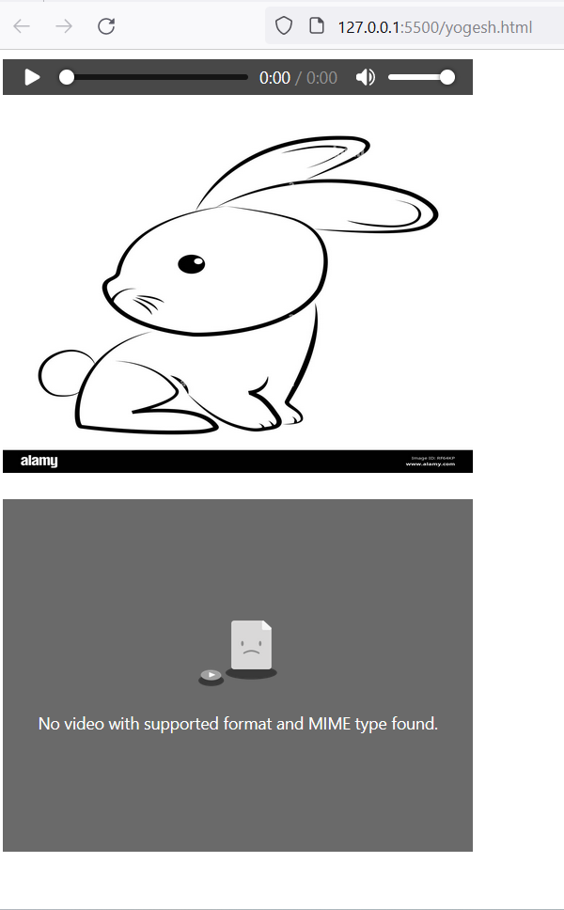

**LAB 5**

**Create the exact table as below**

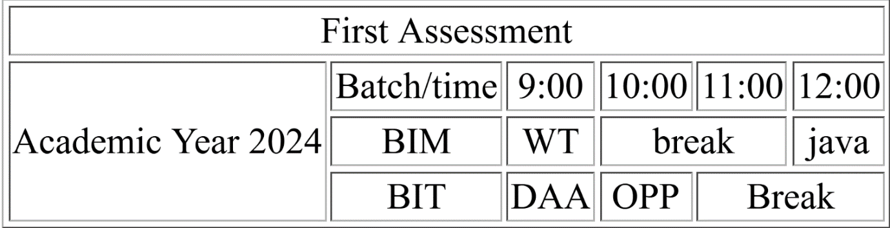

**OUTPUT**

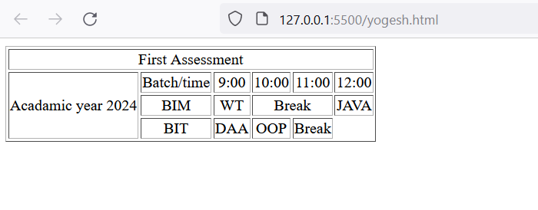

**6. Create following nested table structure**

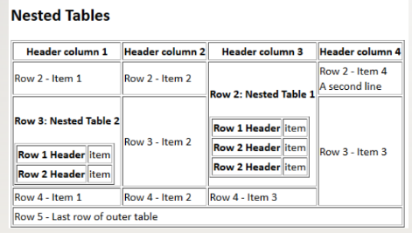

**Output**



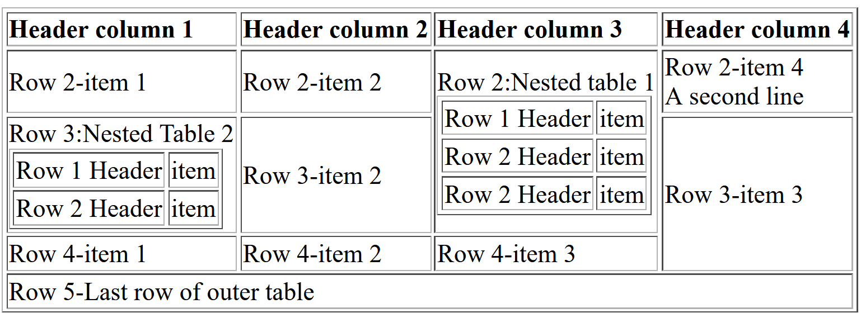

**Lab-7**

**Create the following form. Include placeholder, radio type, pattern for the contact information, set limit for birthday to current day. Provide options and group them according to their category.**

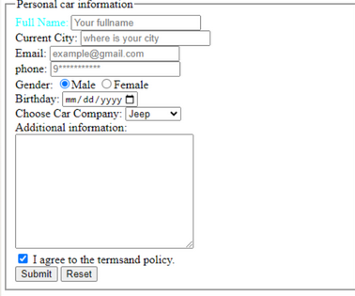

**Coding**

<!DOCTYPE html>

<html lang="en">

<head>

<meta charset="UTF-8">

<meta name="viewport" content="width=device-width, initial-scale=1.0">

<title>Document</title>

</head>

<body>

<form action="" method="get">

<fieldset >

<legend>Personal car information</legend>

<label for="fullname"style="color: aqua;>Full Name:</label>

<input type="text" name="fullname" placeholder="Your fullname"> <br>

<label for="city">Current City:</label>

<input type="text" name="city" id="city" placeholder="where is your city"> <br>

<label for="email">Email:</label>

<input type="email" name="email" id="email" placeholder="example@gmail.com"> <br>

<label for="phone">phone:</label>

<input type="tel" name="phone" id="phone" placeholder="9***********" pattern="9[0-9]{9}">

<br>

<label for="gender">Gender:</label>

<input type="radio" name="gender" id="gender" checked>Male

<input type="radio" name="gender" id="gender">Female <br>

<label for="birthday">Birthday:</label>

<input type="date" name="dob" id="dob" min="1995-10-05" max="2024-01-02"> <br>

<label for="carcompany">Choose Car Company:</label>

<select name="cars" id="casrs">

<optgroup label="American:">

<option value="jeep">Jeep</option>

<option value="ford">ford</option>

<option value="tesla">Tesla</option>

</optgroup>

<optgroup label="Indian">

<option value="maruti">Maruti</option>

<option value="tata">Tata</option>

</optgroup>

</select> <br>

Additional Information:<br>

<textarea name="text" id="" row="25" cols="34"></textarea>

<br>

<input type="checkbox" checked> <label for="terms">I agree

to the terms and policy.</label> <br>

<input type="Submit" name="submit" id="submit">

**Output**

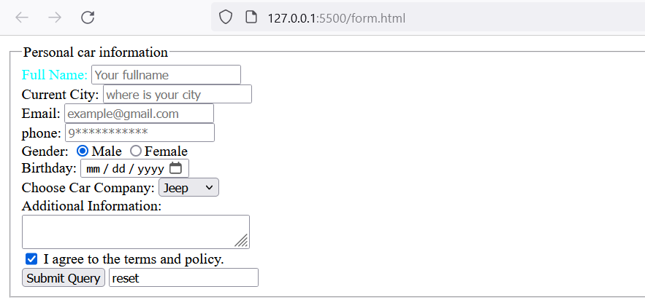

**Lab-8**

**Create the following form as exactly shown in there.**

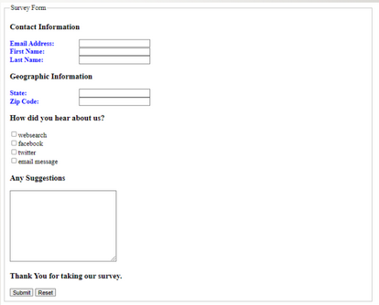

**Coding**

<!DOCTYPE html>

<html lang="en">

<head>

<meta charset="UTF-8">

<meta name="viewport"

content="width=device-width, initial-scale=1.0">

<title>Document</title>

<style>

label{

color: blue;

font-weight: bold;

}

</style>

</head>

<body>

<form action="submit.html" method="get">

<fieldset>

<legend>Survey Form</legend>

<h3>Contact Information</h3>

<label for="email">Email Address:</label>

<input type="email" name="email"><br>

<label for="f_name">First Name:</label>

<input type="text" name="fname"id="fname"><br>

<label for="l_name">Last Name:</label>

<input type="text" name="lname"id="lname">

<h3>Geographic Information</h3>

<label for="state">State:</label>

<input type="text" name="state"id="state"><br>

<label for="zipcode">Zip Code:</label>

<input type="text" name="zipcode">

<h3>How did you hear about us?</h3>

<input type="checkbox"name="websearch">websearch <br>

<input type="checkbox"name="facebook">facebook <br>

<input type="checkbox"name="twitter">twitter <br>

<input type="checkbox"name="emailmsg">email message <br>

<h3>Any Suggestions</h3>

<textarea name="comments" id=""cols="30" rows="10"></textarea>

<h3>Thank You for taking our survey.</h3>

<input type="submit" name="submit">

<!DOCTYPE html>

<html lang="en">

<head>

<meta charset="UTF-8">

<meta name="viewport"content="width=device-width, initial-scale=1.0">

<title>Document</title>

<style>

label{

color: blue;

font-weight: bold;

}

</style>

</head>

<body>

<form action="submit.html" method="get">

<fieldset>

<legend>Survey Form</legend>

<h3>Contact Information</h3>

<label for="email">Email

Address:</label>

<input type="email" name="email"><br>

<label for="f_name">First Name:</label>

<input type="text" name="fname"id="fname"><br>

<label for="l_name">Last Name:</label>

<input type="text" name="lname"id="lname">

<h3>Geographic Information</h3>

<label for="state">State:</label>

<input type="text" name="state" id="state"><br>

<label for="zipcode">Zip Code:</label>

<input type="text" name="zipcode">

<h3>How did you hear about us?</h3>

<input type="checkbox"name="websearch">websearch <br>

<input type="checkbox"name="facebook">facebook <br>

<input type="checkbox"name="twitter">twitter <br>

<input type="checkbox"name="emailmsg">email message <br>

<h3>Any Suggestions</h3>

<textarea name="comments" id=""cols="30" rows="10"></textarea>

<h3>Thank You for taking our survey.</h3>

<input type="submit" name="submit">

<input type="reset" name="reset">

</fieldset>

</form>

</body>

</html>

</fieldset>

</form>

</body>

</html>

**Output**

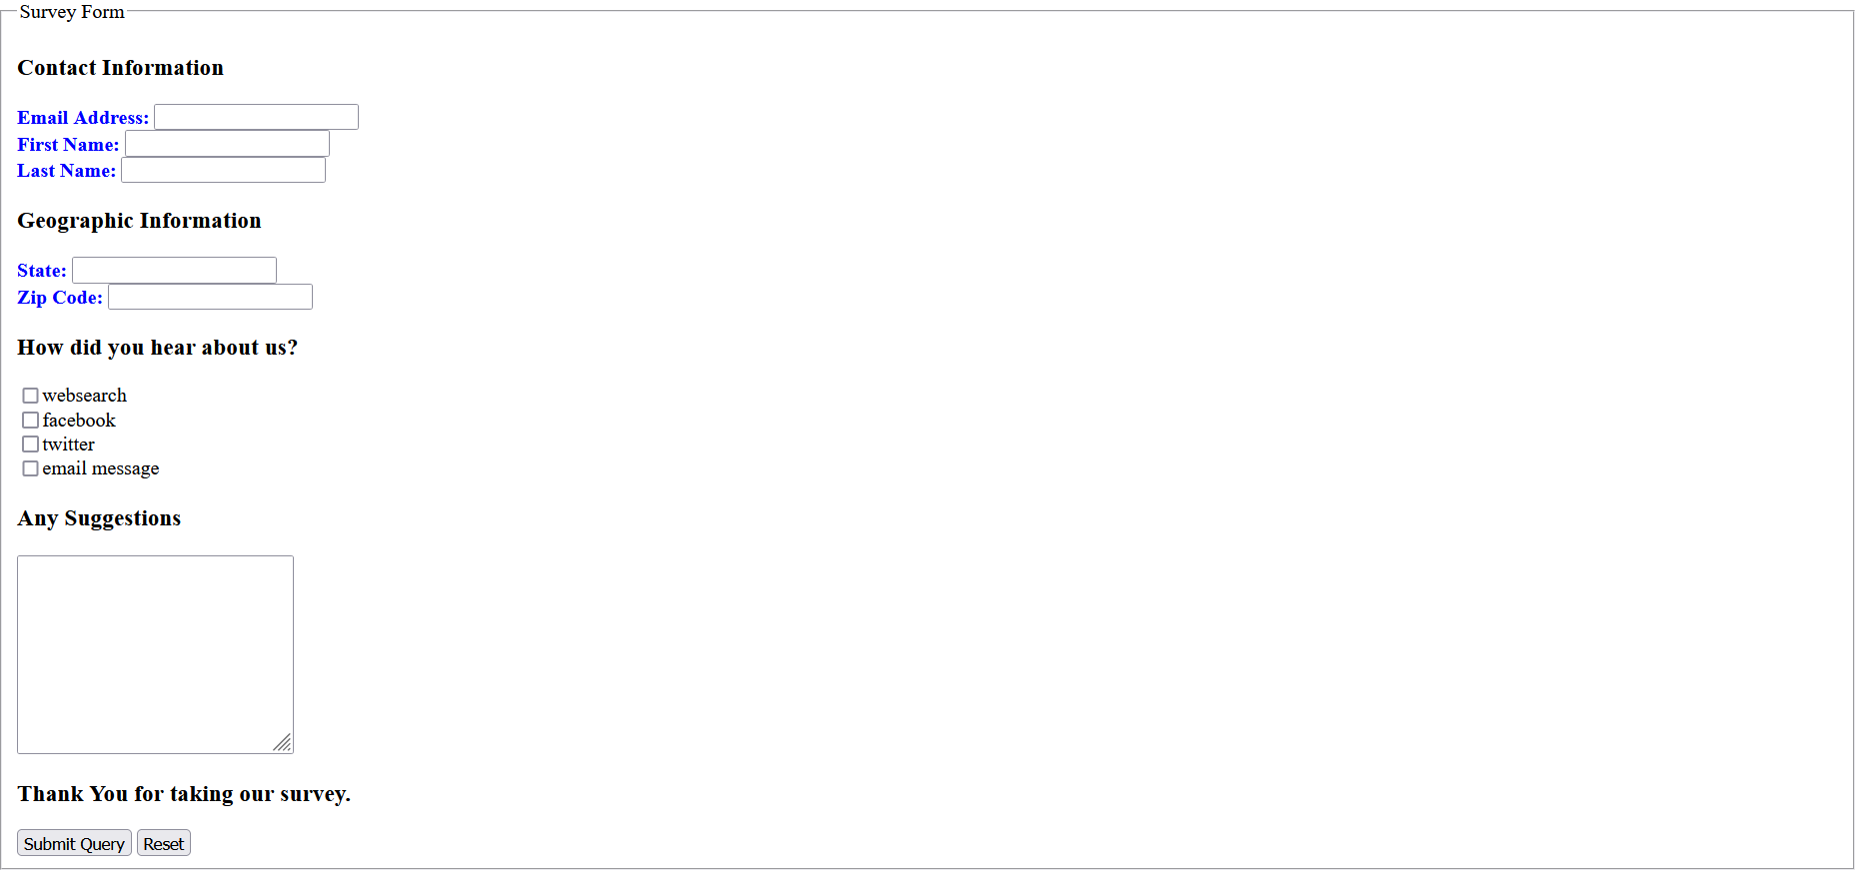

**12. Use CSS selectors(universal selector, element-element selector, element grouping selector, id and class selector) to display as follows.**

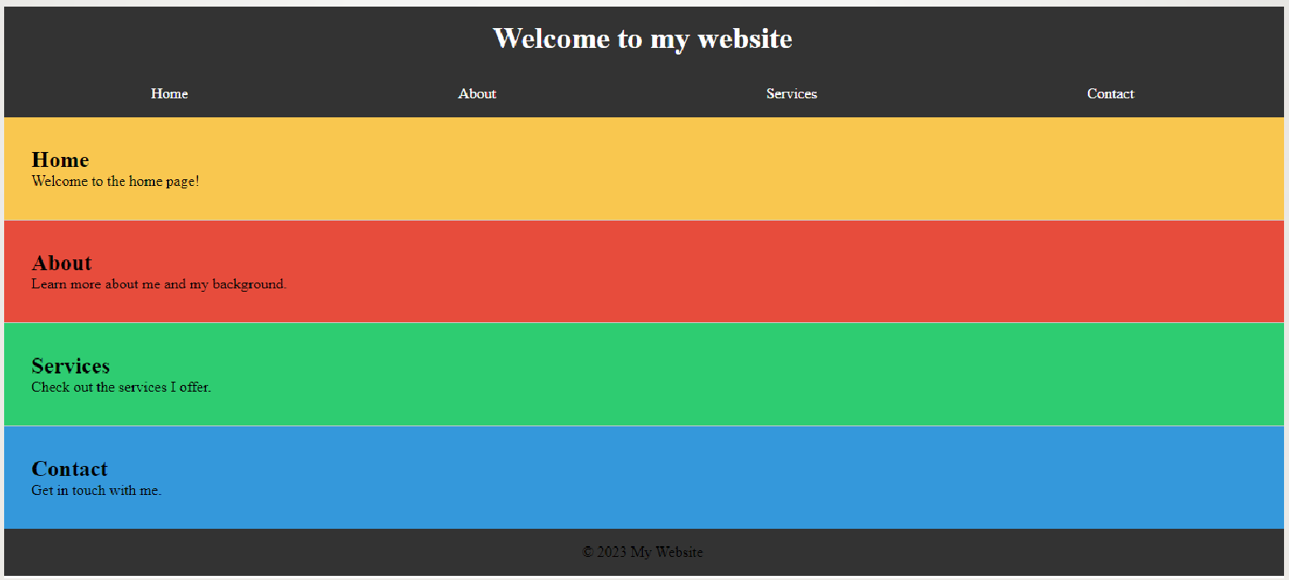

**OUTPUT**

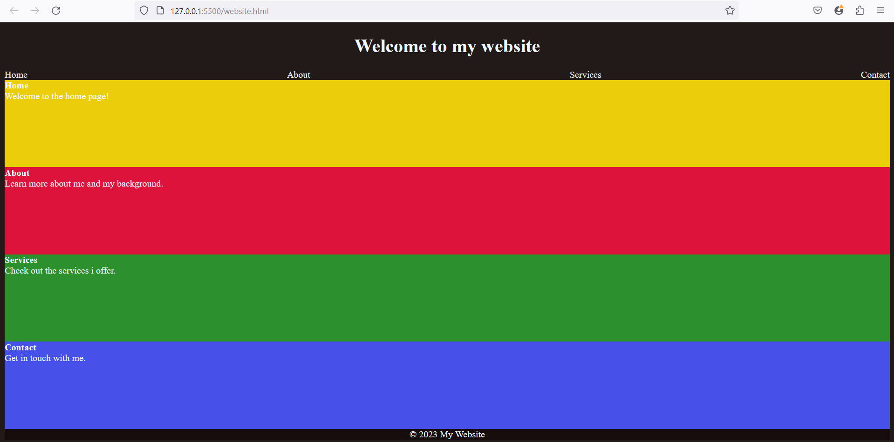

**9. Listing the items using ordered list, unordered list, data definition list.**

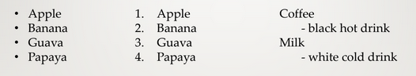

**Output**





**10.Display following CSS Box model using html and CSS.**

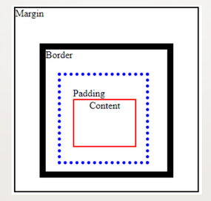

**Output**





11**. Display item in multiple columns using CSS as below**.



**11.** **Use CSS attribute selectors to select and style the different elements of a html document.**

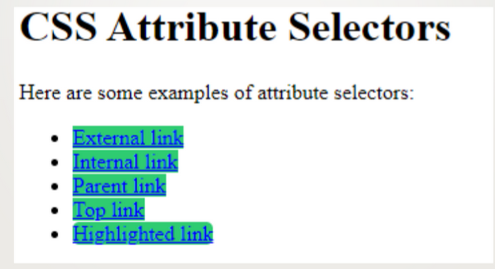

**Output**





**12.** **Use CSS Pseudo-class Selectors on a anchor<a> and input.**

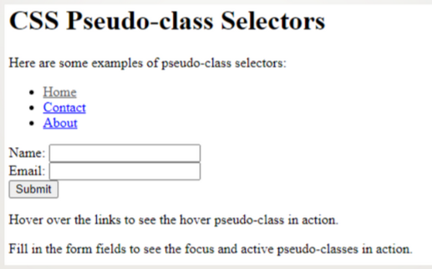

**Output**



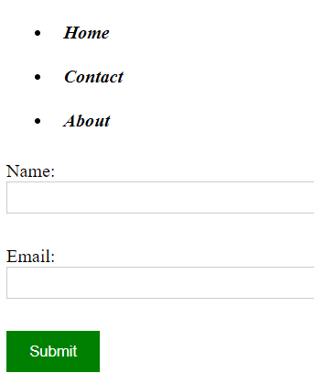

**12.** **Write CSS for Pseudo class selector to add before and after a paragraph.**

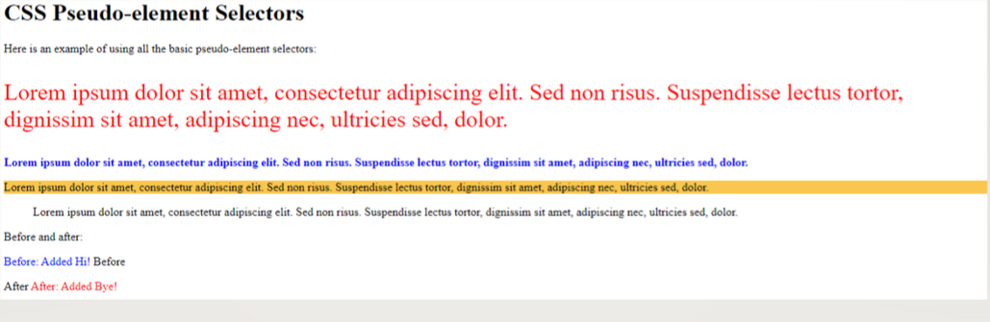

**Output**





**14.** **Display properties inline, inline-block and block.**

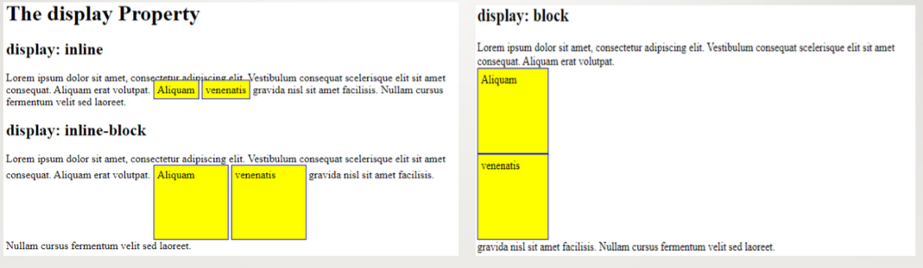

**Output**



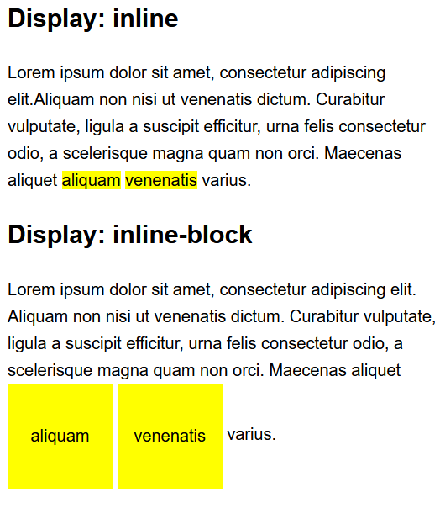

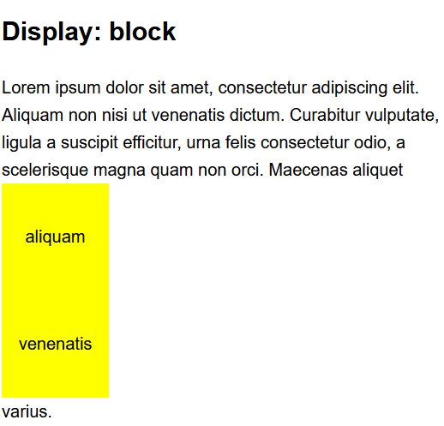

**15.** **Try background property: scroll, fixed, repeat**

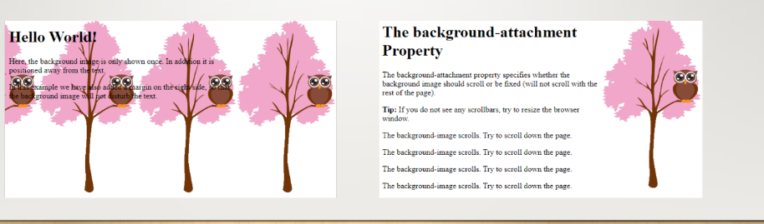

**Output**





**16.** **Design the following template using table structure.**

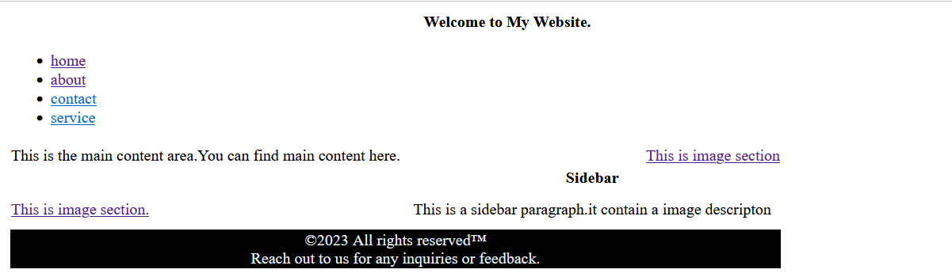

**Output**





**17. Design following using HTML5 elements.**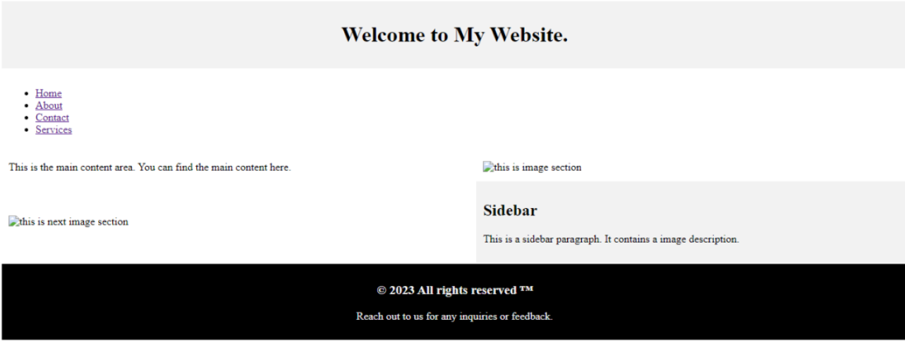

**Output**



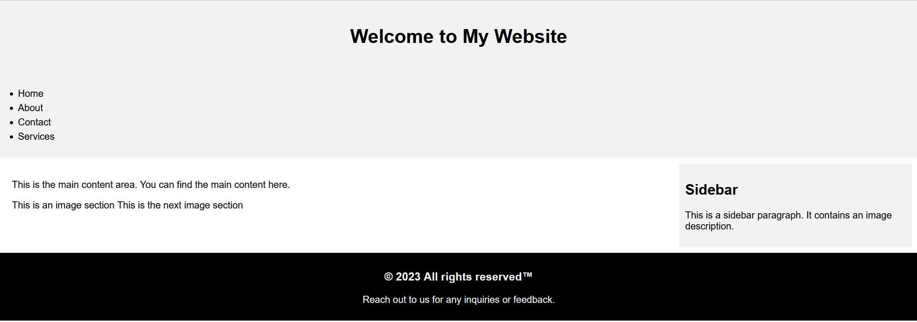

**18** **Design following using table-less design approach**



**Output**





**19.** **Creating the following responsive design using flex and grid respectively.**

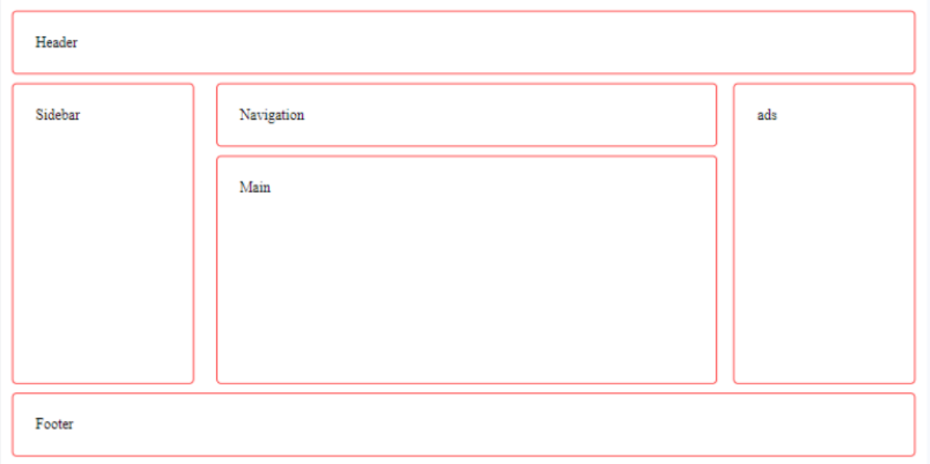

**Output**





**20.** **Creating the following responsive design using flex and grid respectively.**

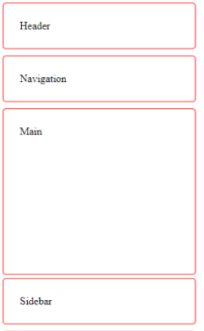

**Output**





**21.** **Create a Responsive Home page design of your website using bootstrap.**

**Consider a mobile, tablet and laptop as different media devices for this task.**

**Output**



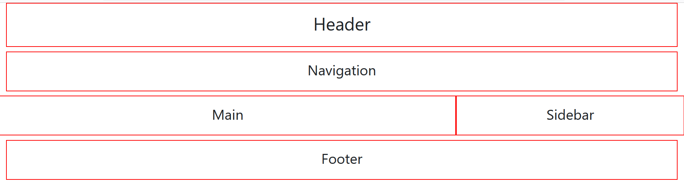

**Output**



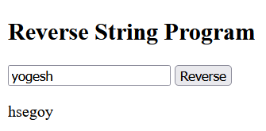

**Output**



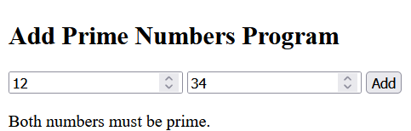

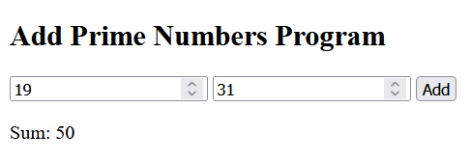

**24. Write a JS program to add two numbers if they are even else find their difference**

**using a user-defined functions.**

**Output**



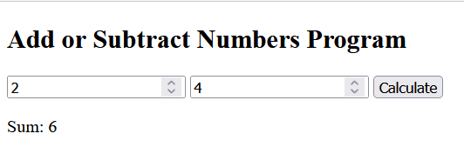

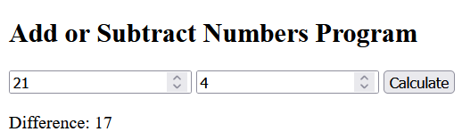

**25. Pass two strings compare them and if they are equal show message “The first**

**string is in uppercase” else “ the strings are not equal”.**

**Output**



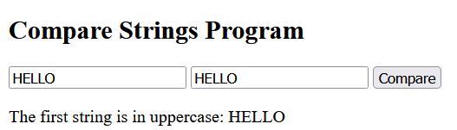

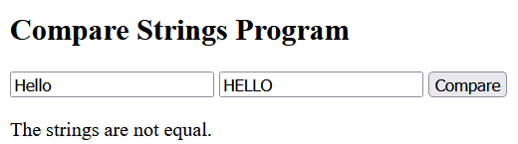

**Output**



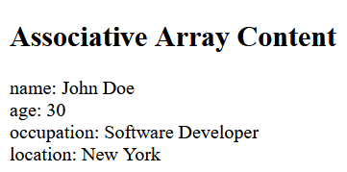

**Output**



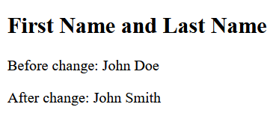

**28.** **Write a JavaScript Program for the following conditions.**

**A. if the given email is a valid email or not? also the email should be @gmail and**

**@hotmail.com**

**B.accept if the phone number is NTC(9841****** or 9851******) or NCELL(980********)**

**C. accept password if the it contains at least one**

**a. Capital Letters**

**b. small Letters**

**c. numbers**

**d. Special Symbols**

**e. Min length of 6**

**Output**



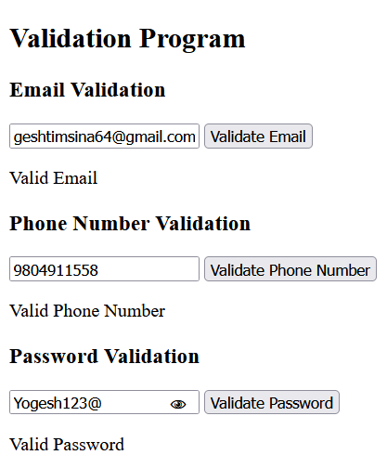



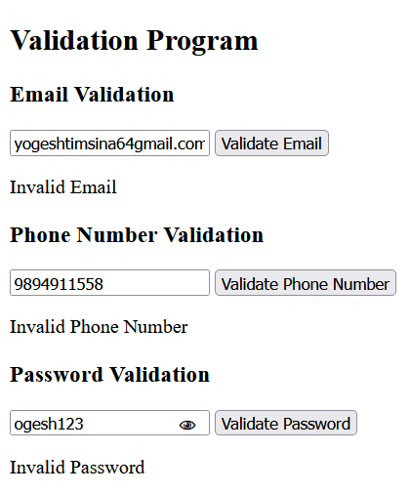

**Output**



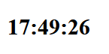

**Output**



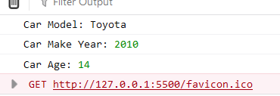

**Output**



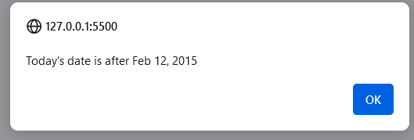

**Output**



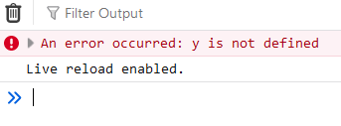

**Output**



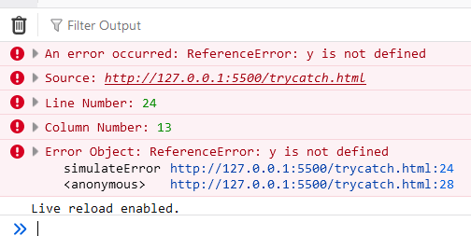

**Output**

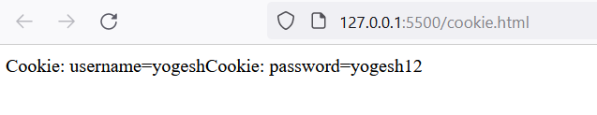

**Output**



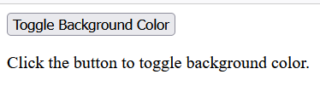



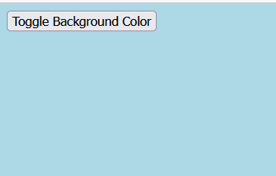

**Output**



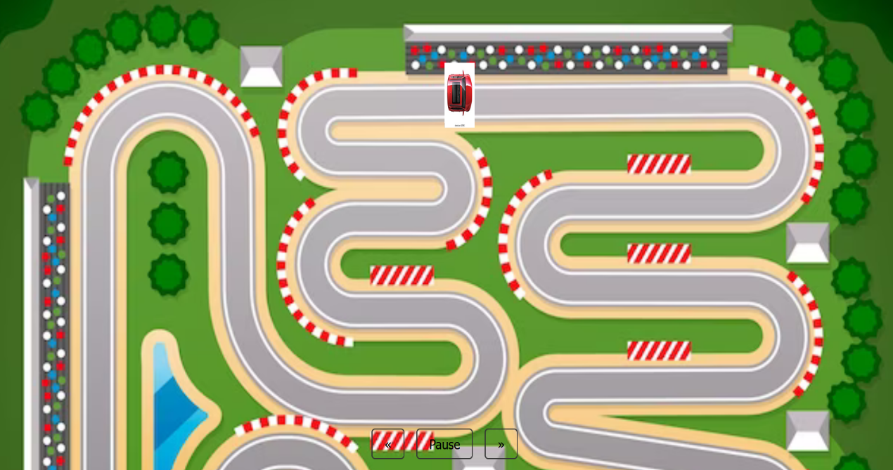

**Output**

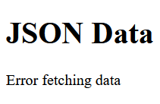

**Output**

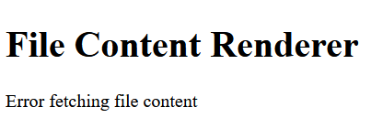

**Lab-39**

**Write it’s XML, DTD, XSD, XSLT to Render in Browser, and**

**XQuery to select book whose price is greater than 200.**

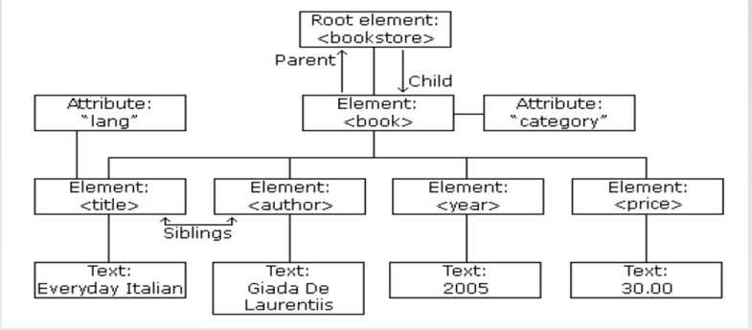

**Coding**

**Xml**

<?xml version="1.0" encoding="UTF-8"?>

<bookstore lang="en">

<book category="cooking">

<title>Everyday Italian</title>

<author>Giada De Laurentiis</author>

<year>2005</year>

<price>30.00</price>

</book>

</bookstore>

**DTD**

<?xml version="1.0" encoding="UTF-8"?>

<!DOCTYPE library[

<!ELEMENT bookstore (book+)>

<!ELEMENT book (title, author, year, price)>

<!ATTLIST book category CDATA #REQUIRED>

<!ELEMENT title (#PCDATA)>

<!ATTLIST title lang CDATA #IMPLIED>

<!ELEMENT author (#PCDATA)>

<!ELEMENT year (#PCDATA)>

<!ELEMENT price (#PCDATA)>]>

<bookstore lang="en">

<book category="cooking">

<title>Everyday Italian</title>

<author>Giada De Laurentiis</author>

<year>2005</year>

<price>30.00</price>

</book>

</bookstore>

**XSD**

<?xml version="1.0"?>

<xs:schema xmlns:xs="http://www.w3.org/2001/XMLSchema">

<xs:element name="bookstore">

<xs:complexType>

<xs:sequence>

<xs:element name="book" type="bookType" minOccurs="1"

maxOccurs="unbounded"/>

</xs:sequence>

</xs:complexType>

</xs:element>

<xs:complexType name="bookType">

<xs:sequence>

<xs:element name="title" type="xs:string"/>

<xs:element name="author" type="xs:string"/>

<xs:element name="year" type="xs:integer"/>

<xs:element name="price" type="xs:decimal"/>

</xs:sequence>

<xs:attribute name="category" type="xs:string" use="required"/>

</xs:complexType>

</xs:schema>

**XSLT**

<!DOCTYPE html>

<html>

<head>

<title>Bookstore</title>

<style>

table {

width: 50%;

border-collapse: collapse;

margin: 20px 0;

}

table, th, td {

border: 1px solid black;

}

th, td {

padding: 8px;

text-align: left;

}

th {

background-color: #f2f2f2;

}

</style>

</head>

<body>

<h2>Bookstore</h2>

<table>

<tr>

<th>Title</th>

<th>Author</th>

<th>Year</th>

<th>Price</th>

<th>Category</th>

</tr>

<tr>

<td>Everyday Italian</td>

<td>Giada De Laurentiis</td>

<td>2005</td>

<td>30.00</td>

<td>cooking</td>

</tr>

</table>

</body>

</html>

**OUTPUT**

**XML**

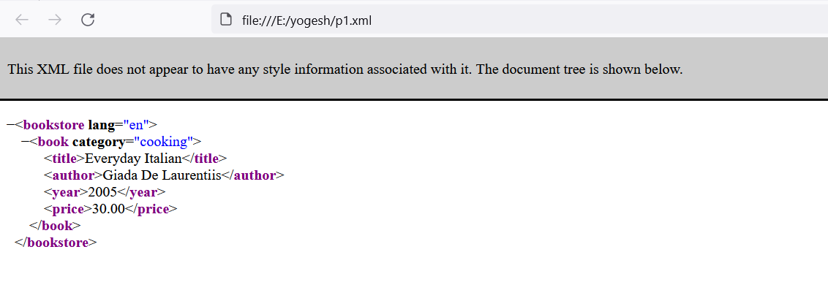

**XSD**

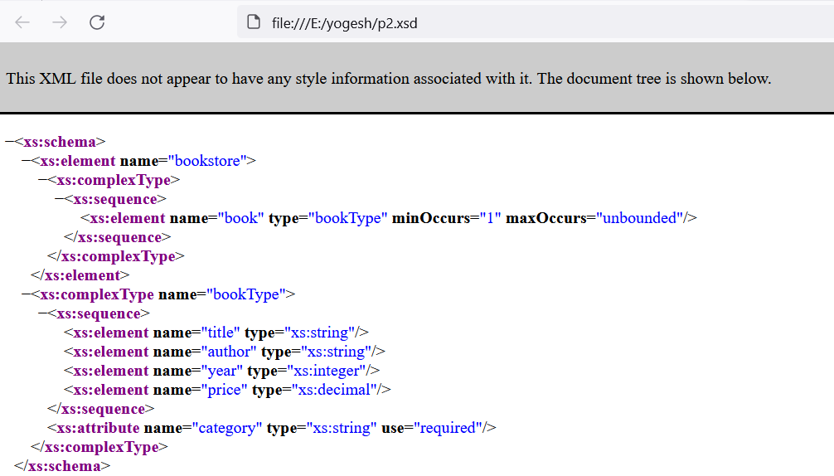

**XSLT**

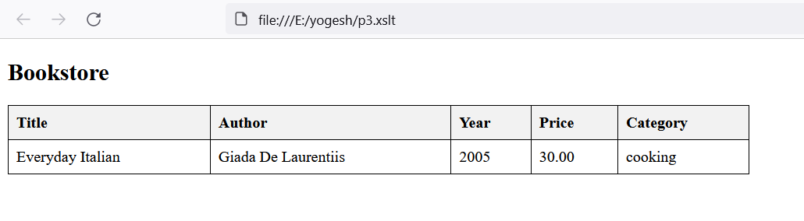

**DTD(VALIDATION)**

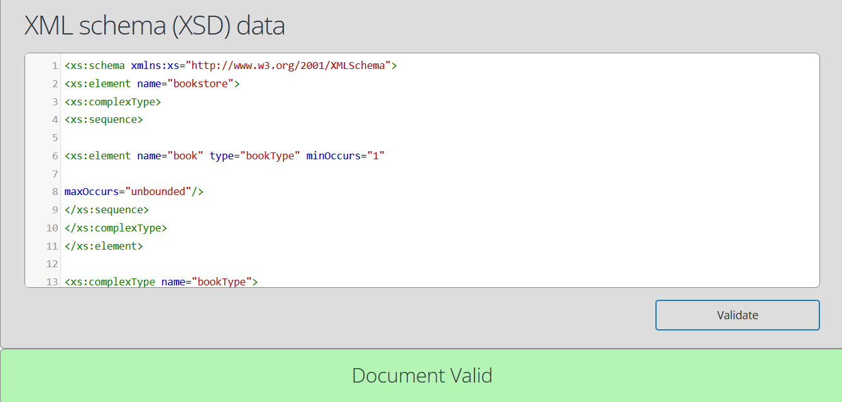

**FINAL PROJECT**

**Coding**

<!DOCTYPE html>

<html lang="en">

<head>

<meta charset="UTF-8">

<meta name="viewport" content="width=device-width, initial-scale=1.0">

<title>चौतारी</title>

<link rel="stylesheet" href="style.css">

</head>

<body>

<header>

<nav>

<div class="logo"><a href="#home"><img src="-high-resolution-logo-black.png" alt="Logo"></a></div>

<ul>

<li><a href="#home">Home</a></li>

<li><a href="#about">About</a></li>

<li><a href="#services">Services</a></li>

<li><a href="#contact">Contact</a></li>

</ul>

</nav>

</header>

<div class="hero" id="home">

<h1>चौतारी</h1>

</div>

<section class="about" id="about">

<div class="container">

<div class="about1">

<h2>About The Website<br></h2>

</div>

<p>चौतारी is a comprehensive IT knowledge<br>it is  hub  for designed and assist individuals <br>in learning about diverse technology topics. <br>Our platform provides valuable resources, tutorials,<br> and expert insights to help you enhance your<br> IT skills and keep up with the latest industry trends.</p>

<div class="about-image">

<img src="https://t4.ftcdn.net/jpg/04/17/28/93/360_F_417289346_hrs0D4Lo8dSv3aWDqkQpRB0U9PbtFX6n.jpg" alt="चौतारी Logo">

</div>

</div>

</section>

<section class="services" id="services">

<div class="container">

<h2>Services</h2>

<div class="service-cards">

<div class="service-card">

<div class="service-image">

<img src="https://i.rtings.com/assets/pages/KSgFV72t/best-laptops-for-working-from-home-20230503-medium.jpg?format=auto" alt="Sharing">

</div>

<h3>SHARING</h3>

<p>This page is used for sharing IT knowledge.</p>

</div>

<div class="service-card">

<div class="service-image">

<img src="https://www.nwkings.com/wp-content/uploads/2024/01/Best-IT-Courses-for-Beginners-blog-thumbnail.jpg" alt="Beginners">

</div>

<h3>BEGINNERS</h3>

<p>GET READY TO ROCK</p>

</div>

<div class="service-card">

<div class="service-image">

<img src="https://www.excelsior.edu/wp-content/uploads/2023/10/benefits-of-information-technology-degree.jpg" alt="Achievement">

</div>

<h3>ACHIEVEMENT</h3>

<p>We fulfill your desire</p>

</div>

</div>

</div>

</section>

<section class="contact" id="contact">

<div class="container">

<h2>Contact Us</h2>

<H3>YOGESH TIMSINA</H3>

<H4>CONTACT:<BR>

yogeshtimsina64@gmail.com

+977 9824070742</H4>

<p>Feel free to reach out to us for any inquiries or support.</p>

</div>

</section>

    <footer>

        <p>&copy; 2024 चौतारी. All Rights Reserved.</p>

    </footer>

</body>

</html>

**Style.css**

body {

margin: 0;

font-family: Arial, sans-serif;

color: #fff;

background-color: #121212;

background-image: url('-high-resolution-logo-white-transparent.png'); background-size: cover;

scroll-behavior: smooth;

}

header {

background-color: rgba(32, 35, 42, 0.9);

width: 100%;

position: fixed;

top: 0;

left: 0;

z-index: 1000;

}

nav {

display: flex;

justify-content: space-between;

align-items: center;

padding: 1em 2em;

}

.logo img {

height: 100px;

}

nav ul {

list-style: none;

display: flex;

gap: 1em;

}

nav ul li a {

text-decoration: none;

color: #61dafb;

}

.hero {

display: flex;

justify-content: center;

align-items: center;

height: 50vh;

background-color: rgba(40, 44, 52, 0.9);

margin-top: 70px;

}

.hero h1 {

font-size: 3em;

}

.container {

padding: 2em;

size: 100px;

text-align: center;

}

.about, .services, .contact {

background-color: rgba(32, 35, 42, 0.9); padding: 2em 0;

}

.about .container {

display: flex;

align-items: center;

justify-content: space-between;

}

.about-image img {

width: 200px;

}

.services .container, .contact .container {

text-align: center;

}

.service-cards {

display: flex;

justify-content: space-around;

flex-wrap: wrap;

}

.service-card {

background-color: rgba(40, 44, 52, 0.9);

margin: 1em;

padding: 1em;

border-radius: 8px;

width: 30%;

box-shadow: 0 4px 8px rgba(0, 0, 0, 0.2);

}

.service-image img {

width: 100%;

height: auto;

border-radius: 8px;

}

footer {

background-color: rgba(32, 35, 42, 0.9);

text-align: center;

padding: 1em 0;

}

.about1{

text-align: center;

color: blue;

}

**OUTPUT**



